**Name:** Marija Milojković

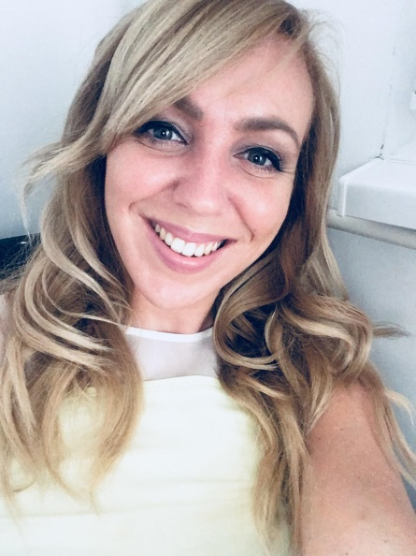

**Date and place of birth:** June, 28th 1990, Novi Sad

**Address:** Novi Sad, Zeleznicka 9/2/15

**Contact:** 069/746027

**Mail:** [marijamilojkovic13@gmail.com](mailto:marijamilojkovic13@gmail.com)

**Education:**

* Economic technician – High school of economics in Odzaci, graduated in 2009
* Bachelor of laws – Faculty of law, University of Novi Sad, graduated in 2013, grade point average: 8,74
* Master of laws – Faculty of law, University of Novi Sad, graduated in 2015, grade point average: 9,80, master thesis: “The right to fair trial in criminal law”

**Working experience:**

* *December 2013 – June 2014* – legal trainee in law office (civil and labor law)
* *September 2014 – April 2015* – legal trainee in Primary court in Novi Sad (civil and family law)
* *October 2015 – May 2016* – legal trainee in Primary court in Novi Sad (labor and criminal law)
* *June 2016 – January 2017* – legal trainee in Commercial court in Novi Sad
* *August 2017 – January 2018* – associate in law office (civil, labor law, intellectual property law, misdemeanor law)
* Enlisted in Lawyers Bar from *February 2018*

**Competitions and seminars:**

* *April 2012* – regional competition for the best application to European Court of Human Rights (Sarajevo, Bosnia and Herzegovina) – 3rd place
* *April 2012* – attendant of seminar about humanitarian law, organized by Civil Right Defenders organization (Sarajevo)
* *February 2013* – European competition for the best application to European Court of Human Rights (in English) – 2nd place
* *February 2013* – attendant of seminar about procedures before European Court of Human Rights and visitor of Council of Europe
* *May 2015* – September 2015 – USA work and travel program participant

**Foreign languages:**

* Fluent in English – completed the proficiency level course of reading, speaking and writing in English, have been expertizing it while living and working in the USA for 5 months
* Basic in German – completed the first level course of reading, speaking and writing in German

**Skills:**

* Touch tiping
* Researcher in HUDOC, EUR-lex, profisistem, paragraflex database of practice, reading practice in English
* User of WIPO application - international intellectual property database

**Other characteristics:**

* Organized, inquisitive, responsible, tempered, diligent, dedicated