**CURRICULUM VITAE**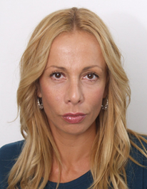

Name: **JELENA ĆETKOVIĆ**

Address: Kralja Milutina 55, Belgrade

Date of Birth: 25.10.1976

**Contact:**

Email: jjelenacetkovic@gmail.com,

Telephone:+381 65 3777714

